Summer Break Research Proposal

A Comprehensive study of FF-NN, LSTM-RNN and BLSTM for URDU language Data set
- Introduction
Speech Recognition for Urdu language is an interesting and less developed task. This is primarily due to the fact that linguistic resources such as rich corpus are not available for Urdu. Yet, few attempts have been made for developing Urdu speech recognition frameworks using the traditional approaches such as Hidden Markov Models and Neural Networks. Support Vector Machine (SVM) classifier, a random forest (RF) classifier and linear discriminant analysis classifier. Recurrent neural networks (RNNs) are a powerful model for sequential data. Recent experiments show that deep bidirectional long short term memory (BLSTM) recurrent neural network acoustic models outperform feed forward neural networks for automatic speech recognition (ASR) for English language.
It is clear from the literature that most of the work has been done on Speech Recognition in English language. Other than English, research has been carried out in, Arabic, and Hindi. Literature suggests that less work has been done in Urdu Language. A lot of research work can be conducted to analyze the performance of different algorithms of DNN. This Research will do a comparative study and comprehensive overview of FF-NN, LSTM-RNN and BLSTM ASR, for Urdu language.

Objective: Overall and Specific
- To investigated FF-NN, LSTM-RNN and BLSTM for URDU language data set (Using 2017 Paper configuration (provided by Dr. Ali). The training configuration files are publicly available)
- Comparison of LSTM with Muhammad Irfan finding (using LSTM RNN with 5 hidden layer)
- Calculate WER, Accuracy.
- The effect of different parameter (in term of proportionality)
- Suggesting optimal network topology, sequence chunking and batch sizes, optimization methods, regularization function for Urdu data set.

- Review of Literature
Automatic Speech Recognition of Urdu Digits with Optimal Classification Approach
Hazrat Ali, An Jianwei, Khalid Iqbal International Journal of Computer Applications (09758887) Volume 118 - No. 9, May 2015
A COMPREHENSIVE STUDY OF DEEP BIDIRECTIONAL LSTM RNNS
FOR ACOUSTIC MODELING IN SPEECH RECOGNITION
Albert Zeyer, Patrick Doetsch, Paul Voigtlaender, Ralf Schluter, Hermann Ney , ICASSP 2017 IEEE
NEW TRENDS IN MACHINE LEARNING FOR SPEECH RECOGNITION
Inge GAVAT, Diana MILITARU, Proceedings of the Annual Symposium of the Institute of Solid Mechanics and Session of the Commission of Acoustics, SISOM 2015 Bucharest 21-22 May

- Methodology & Estimation Procedures

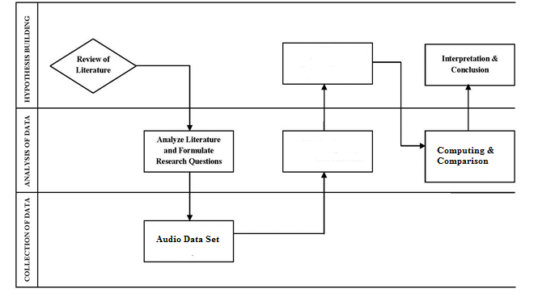

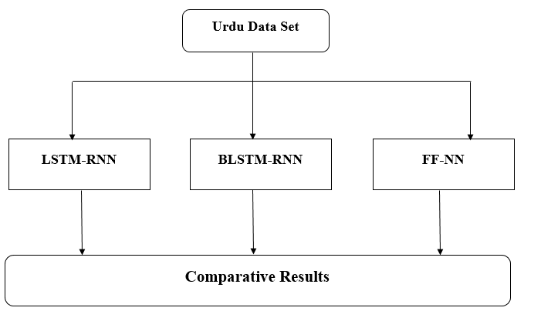

Experiment Details:
50 hours speech data for training
2.3 hours for evaluation
S NO. | Variable
1 | Number of layer | 5 | Also for 1 to 8
2 | Number of nodes | 500 | Also for 600,700,800
3 | Number of epochs | 30 | Also 5, 10 , 30
4 | Cross validation
5 | Cross entropy
6 | Initial Learning rate | 10⁻³
7 | Number of chunks | 40 | From 20 to 80
8 | Window time step
9 | Max window size
Optimization function
1 | stochastic gradient descent | With 32,33 momentum
2 | stochastic gradient descent | Nesterov momentum
3 | mean-normalized SGD
Some other optimization function effects were also studied
Regularization method
1 | Standard L2 Regularization
2 | Drop out regularization
3 | Combination of both method
Effect of no pre training and pre training
1 | Number of Layers vs WER vs Pre-training vs No pre-training

Result Validation/Evaluation:
- Recognition Rate
- Time
- WER
- Accuracy

